

**PES UNIVERSITY**

**(Established under Karnataka Act No. 16 of 2013) 100 Feet Ring Road, BSK III Stage,**

**Bengaluru-560 085**

**Department of Electronics and Communication Engineering**

**Special Topic:**

**Neural Network Control of robot manipulator**

**Project Title:**

**Design of controllers for a two-link robot manipulator**

**Group member Details:**

**Name: A Anirudh Simha**

**SRN: PES1UG21EC001**

**Name: Aditya R G**

**SRN: PES1UG21EC017**

**Name: Akash Ravi Bhat**

**SRN: PES1UG21EC025**

**Faculty Name:**

**Dr. Rashmi N U**

**MATLAB CODES:**

1. **Main File**

clc;close all; clear all;

t0= 0 ; tf=10 ; T=10;

%x0= [0.1 0 0 0 ]' ; %input for PD & gravity PD controller

x0=[10,0,0,0]; %Classical PD controller input

%x0 =[0.1 0 0 0 0 0]'; %PID controller input

%x0=[0.1 ,1, 0 ,0, 0.1 ,0.1];%Adaptive controller input

%[t,x]= ode23(@fblinct,[t0 tf],x0) ;

[t,x]=ode23(@robctl,[t0 tf],x0);

%[t,x]=ode23(@robadapt,[t0 tf],x0); % Adaptive Controller

yd= sin(2*pi*t/T) ;

e= yd - x;

[qd,e]= robout(t,x);

plot(t,[yd,x(:,1)])

plot(t,x(:,2))

plot(t,e) %Normal plot

figure;

%plot(t,x(:,1),'-c',t,qd(:,1),'--k') %Plot for adaptive controller

legend("e1","e2")

title("Tracking error v/s Time ");

ylabel("Tracking error");

xlabel("Time");

figure;

plot(t,qd);

legend("e1","e2")

title("Joint angle v/s Time ");

ylabel("Tracking error");

xlabel("Time");

1. **Robctl code:**

function xdot= robctl(t,x) ;

% ----------------------------------------------------------

% COMPUTE CONTROL INPUT FOR ROBOT ARM

% compute desired trajectory

period= 2 ;

amp1= 0.1 ;

amp2= 0.1 ;

fact= 2*pi/period ;

sinf= sin(fact*t) ;

cosf= cos(fact*t) ;

qd= [amp1*sinf amp2*cosf]' ;

qdp= fact*[amp1*cosf -amp2*sinf]' ;

qdpp= -fact^2*qd ;

% PD Computed-Torque control input

m1= 1 ; m2= 1 ; a1= 1 ; a2= 1 ; g= 9.8 ; % arm parameters

kp= 100 ; kv= 20 ; % controller parameters

ki=20; %PID

% tracking errors

e= qd - [x(1) x(2)]' ;

ep= qdp - [x(3) x(4)]' ;

% computed inertia M(q) and nonlinear terms N(q,qdot)

M11= (m1 + m2)*a1^2 + m2*a2^2 + 2*m2*a1*a2*cos(x(2)) ;

M12= m2*a2^2 + m2*a1*a2*cos(x(2)) ;

M22= m2*a2^2 ;

N1= -m2*a1*a2*(2*x(3)*x(4) + x(4)^2)*sin(x(2)) ;

N1= N1 + (m1 + m2)*g*a1*cos(x(1)) + m2*g*a2*cos(x(1) + x(2));

N2= m2*a1*a2*x(3)^2*sin(x(2)) + m2*g*a2*cos(x(1) + x(2)) ;

% PD CT control torques

s1= qdpp(1) + kv*ep(1) + kp*e(1) ;

s2= qdpp(2) + kv*ep(2) + kp*e(2) ;

tau1= M11*s1 + M12*s2 + N1 ;

tau2= M12*s1 + M22*s2 + N1 ;

% PID CT control torques

%s1= qdpp(1) + kv*ep(1) + kp*e(1) + ki*x(5) ;

%s2= qdpp(2) + kv*ep(2) + kp*e(2) + ki*x(6) ;

%tau1= M11*s1 + M12*s2 + N1 ;

%tau2= M12*s1 + M22*s2 + N2 ;

%xdot(5)= e(1);

%xdot(6)= e(2);

% Gravity PD Controller

% % computed gravity terms

G1= (m1 + m2)*g*a1*cos(x(1)) + m2*g*a2*cos(x(1) + x(2));

G2= m2*g*a2*cos(x(1) + x(2)) ;

% PD CT control torques

s1= kv*ep(1) + kp*e(1) ;

s2= kv*ep(2) + kp*e(2) ;

tau1= s1 + G1;

tau2= s2 + G2;

%Classical Joint Controller PD

tau1=kv*ep(1)+kp*e(1);

tau2=kv*ep(2)+kp*e(2);

tau=[tau1;tau2];

% ----------------------------------------------------------

% ROBOT ARM DYNAMICS

m1= 1 ; m2= 1 ; a1= 1 ; a2= 1 ; g= 9.8 ; % arm parameters

% inertia M(q) and nonlinear terms N(q,qdot)

M11= (m1 + m2)*a1^2 + m2*a2^2 + 2*m2*a1*a2*cos(x(2)) ;

M12= m2*a2^2 + m2*a1*a2*cos(x(2)) ;

M22= m2*a2^2 ;

N1= -m2*a1*a2*(2*x(3)*x(4) + x(4)^2)*sin(x(2)) ;

N1= N1 + (m1 + m2)*g*a1*cos(x(1)) + m2*g*a2*cos(x(1) + x(2));

N2= m2*a1*a2*x(3)^2*sin(x(2)) + m2*g*a2*cos(x(1) + x(2)) ;

% Inversion of M(q) (for large values of n, use least-squares)

det= M11*M22 - M12*M12 ;

MI11= M22/det ;

MI12= -M12/det ;

MI22= M11/det ;

% state equations

xdot(1)= x(3) ;

xdot(2)= x(4) ;

xdot(3)= MI11*(-N1 + tau1) + MI12*(-N2 + tau2) ;

xdot(4)= MI12*(-N1 + tau1) + MI22*(-N2 + tau2) ;

xdot=xdot';

end

1. **Robout code:**

% file robout.m

function [qd,e]= robout(t,x)

% compute desired trajectory

period= 2 ; amp1= 0.1 ; amp2= 0.1 ;

fact= 2*pi/period ;

sinf= sin(fact*t) ;

cosf= cos(fact*t) ;

qd= [amp1*sinf amp2*cosf] ;

% tracking errors

e= qd - x(:,1:2) ;

end

**Implementation of PID controller**

Tracking error graph:

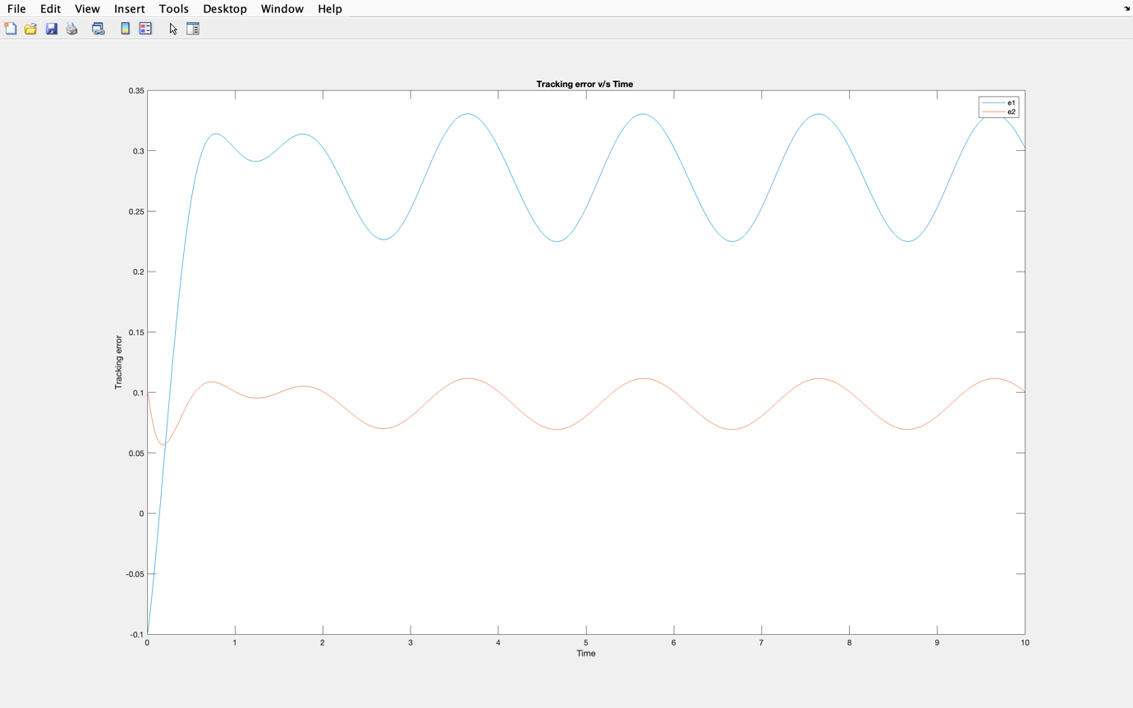

Output graph:

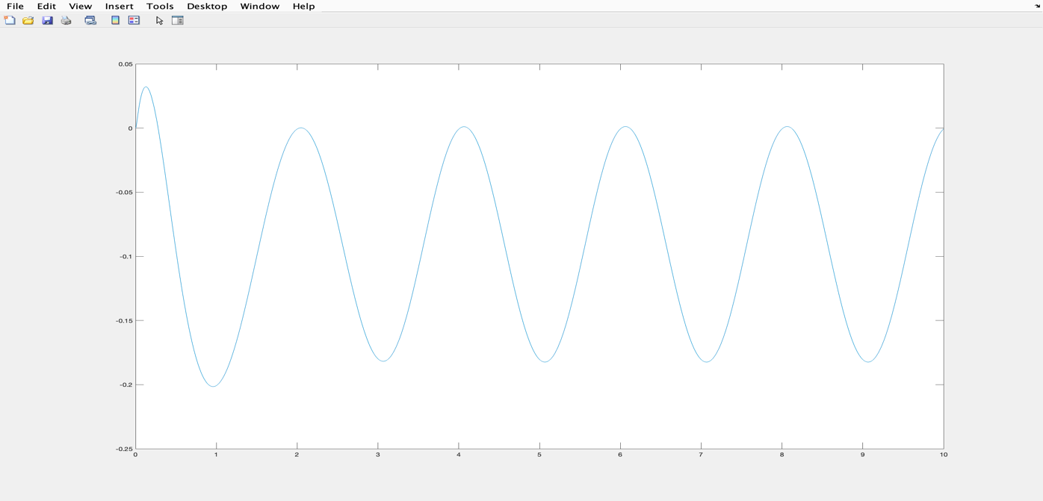

Joint angle graph:

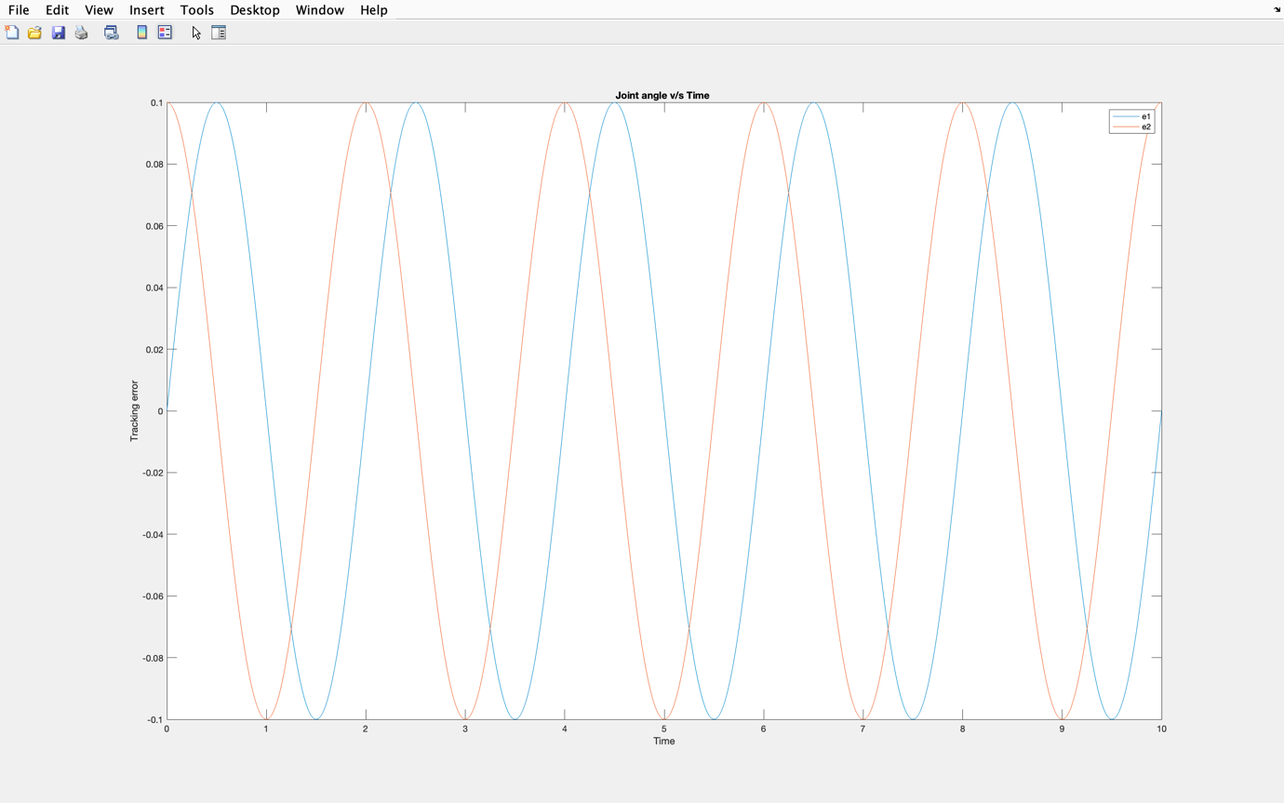

Conclusion:

The PID controller was successfully implemented and outputs obtained were verified

**Implementation of PD controller**

Joint angle graph:

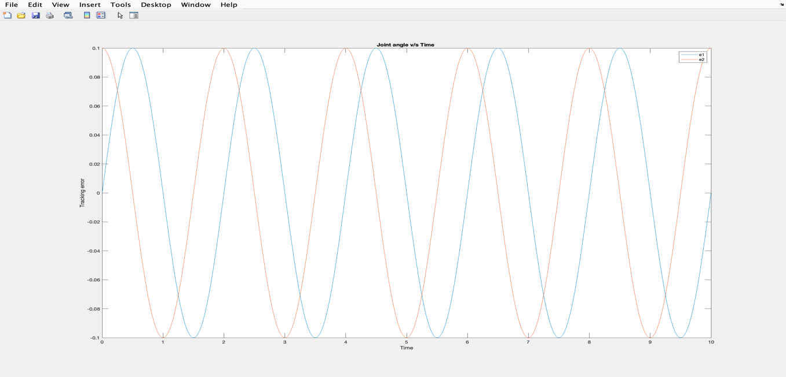

Output graph:

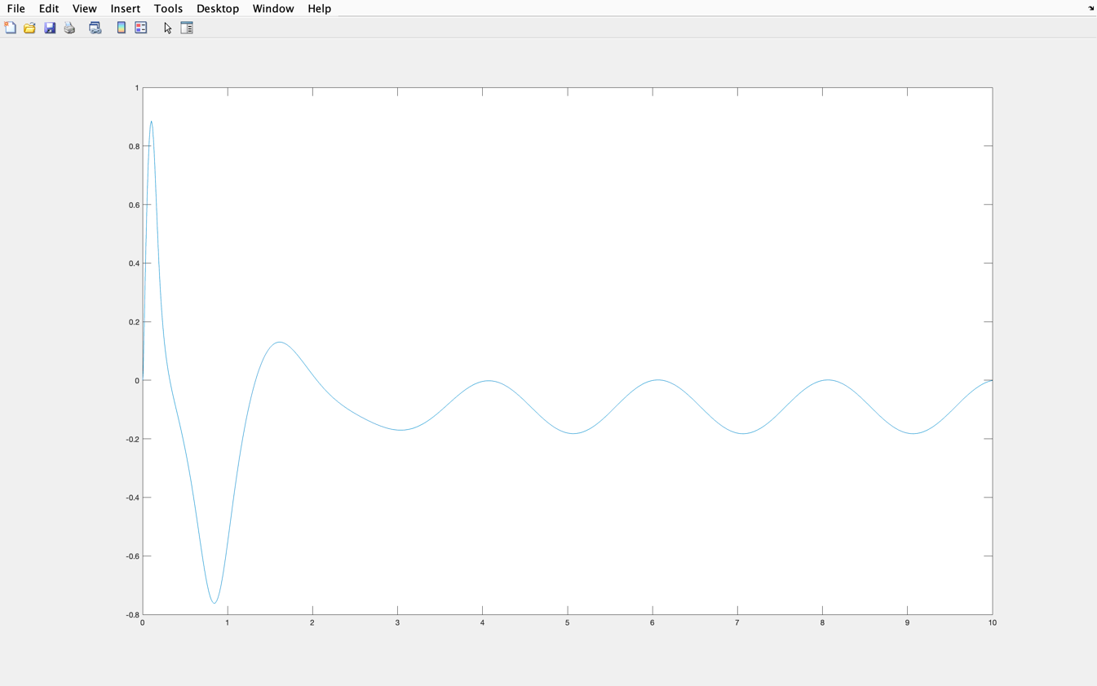

Tracking error graph:

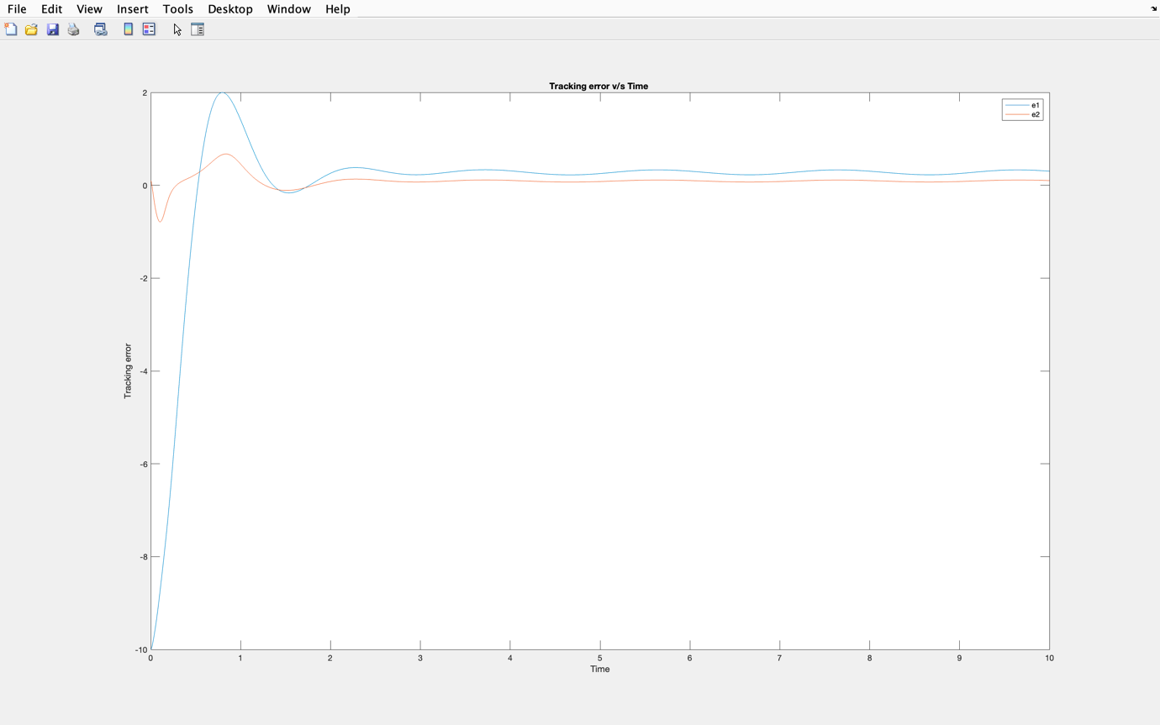

Conclusion:

The PD controller was successfully implemented and outputs obtained were verified

**Implementation of PD Gravity controller**

Output graph:

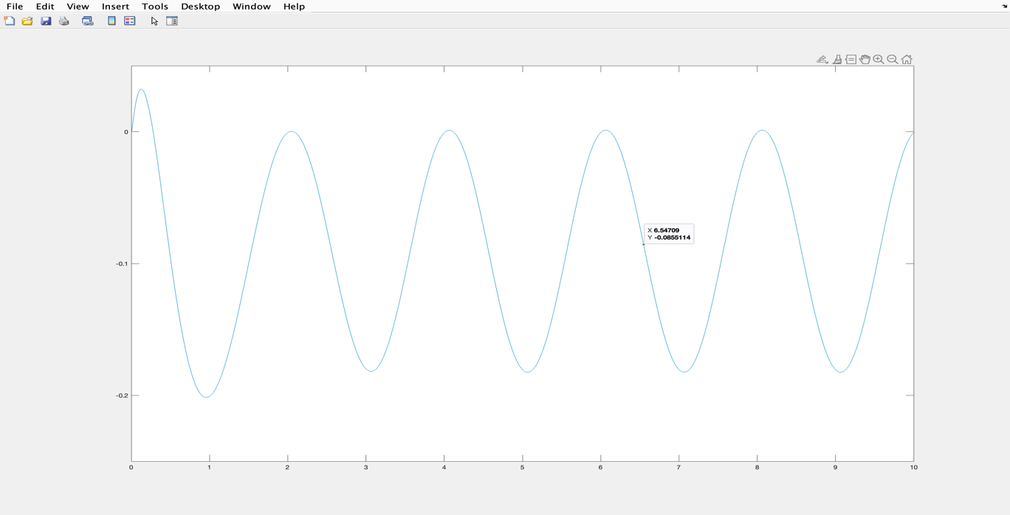

Tracking error graph:

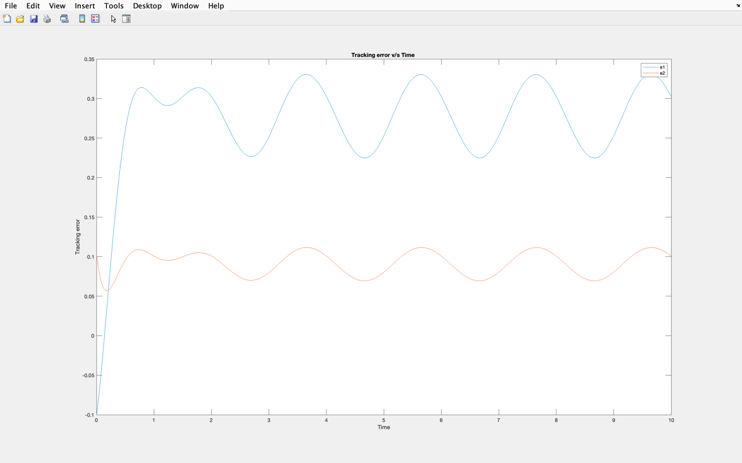

Joint angle graph:

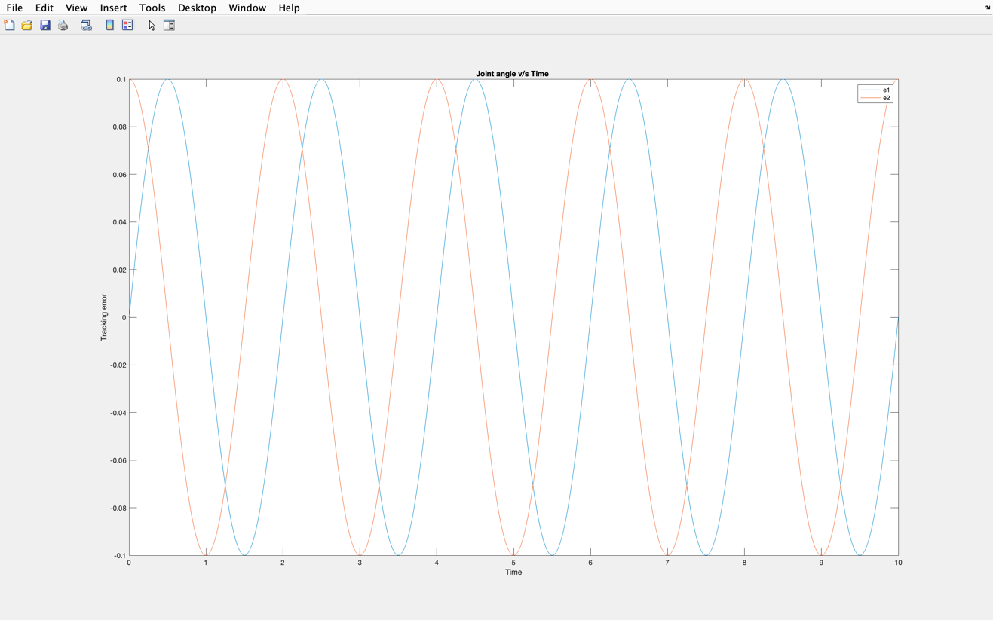

Conclusion:

The PD GRAVITY controller was successfully implemented and outputs obtained were verified

1. **Robadapt code(for adaptive controller)**

function xdot= robadapt(t,x) ;

% compute desired trajectory as in Fig. 3.3.2

% Use period= 2*pi ; amp1= 1 ; amp2= 1 ;

% Adaptive control input

m1= 0.8 ; m2= 2.3 ; a1= 1 ; a2= 1 ; g= 9.8 ; % arm parameters

Kv= 20*eye(2) ; lam= 5*eye(2); gam= 10*eye(2) ; % controller parameters

period= 2 ;

fact= 2*pi/period ;

sinf= sin(fact*t) ;

cosf= cos(fact*t) ;

qd= [a1*sinf a2*cosf]' ;

qdp= fact*[a1*cosf -a2*sinf]' ;

qdpp= -fact^2*qd ;

% tracking errors

e= qd - [x(1) x(2)]' ;

ep= qdp - [x(3) x(4)]' ;

r= ep + lam*e ;

% compute regression matrix

f= qdpp + lam*ep ;

W(1,1) = a1^2*f(1) + a1*g*cos(x(1)) ;

W(1,2) = (a2^2 + 2*a1*a2*cos(x(2)) + a1^2)*f(1)

+ (a2^2 + a1*a2*cos(x(2)))*f(2)

- a1*a2*x(4)*(qdp(1)*sin(x(2)) + lam(1,1)*e(1))

- a1*a2*(x(3)+ x(4))*(qdp(2)+sin(x(2)) + lam(2,2)*e(2))

+ a2*g*cos(x(1) + x(2)) + a1*g*cos(x(1)) ;

W(2,1) = 0 ;

W(2,2) = (a2^2 + a1*a2*cos(x(2)))*f(1) + a2^2*f(2)

+ a1*a2*(qdp(1) + lam(1,1)*e(1))*sin(x(2))

+ a2*g*cos(x(1) + x(2)) ;

% control torques. Parameter estimates are [x(5) x(6)]’

tau= Kv*r + W*[x(5) x(6)]';

tau1= tau(1) ; tau2= tau(2) ;

% parameter updates

phidot= gam*W'*r ;

xdot(5)= phidot(1) ;

xdot(6)= phidot(2) ;

xdot=xdot';

end

**Implementation of adaptive controller**

Tracking error graph:

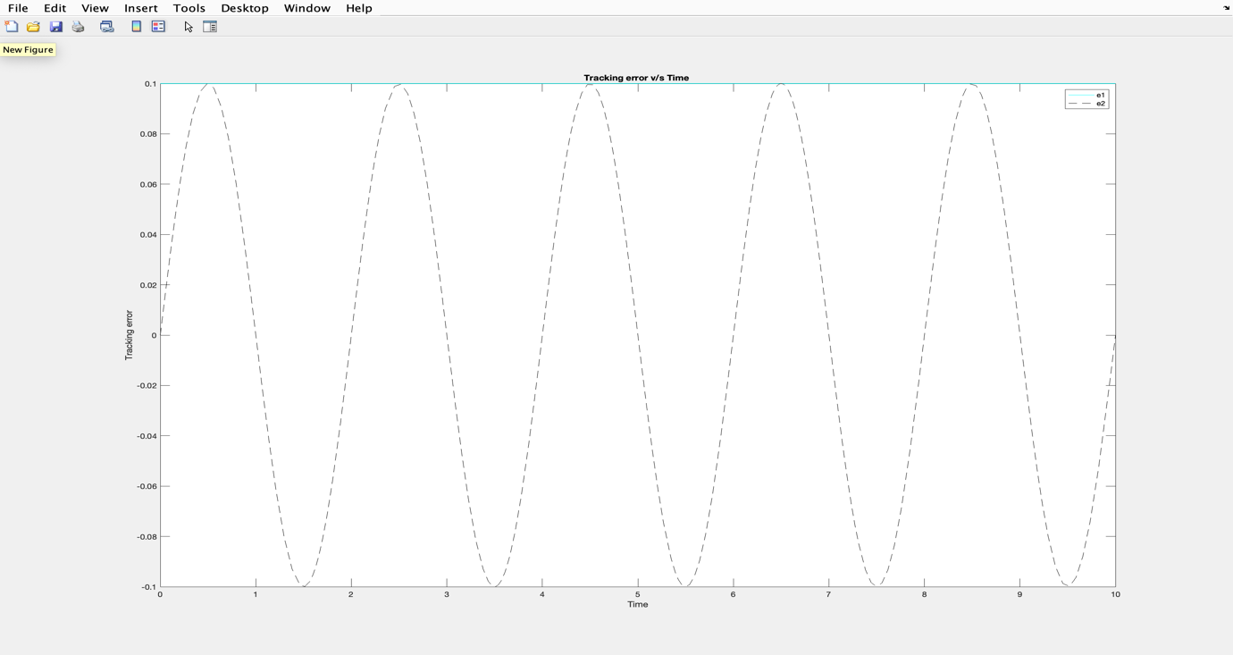

Joint angle graph:

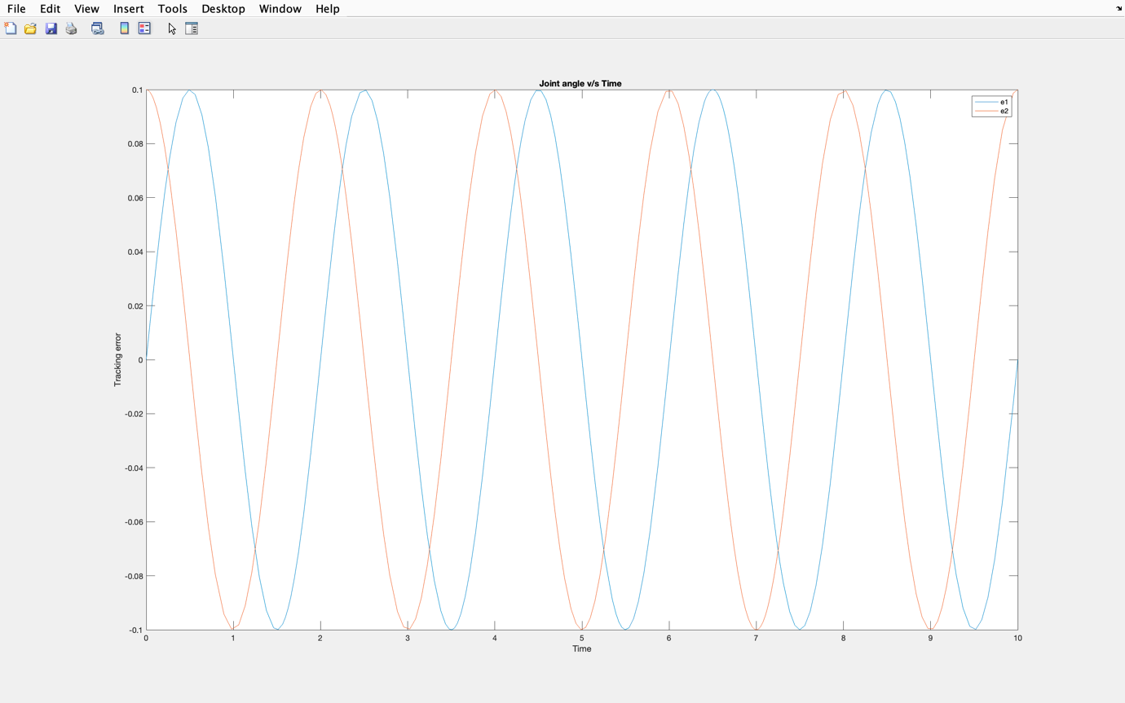

Conclusion:

The ADAPTIVE controller was successfully implemented and outputs obtained were verified

1. **Robctlflnn code(for FLNN controller)**

function xdot = robctlflnn(t, x)

% COMPUTE CONTROL INPUT FOR ROBOT ARM

% compute desired trajectory

period = 2; amp1 = 1; amp2 = 1;

fact = 2 * pi / period;

sinf = sin(fact * t);

cosf = cos(fact * t);

qd = [amp1 * sinf amp2 * cosf]';

qdp = fact * [amp1 * cosf -amp2 * sinf]';

qdpp = -fact^2 * qd;

% Tracking errors

e = qd - [x(1) x(2)]';

ep = qdp - [x(3) x(4)]';

% FLNN Controller parameters

w1 = randn(); % Weight for error e1

w2 = randn(); % Weight for error e2

b = randn(); % Bias

% FLNN Controller output

flnn_output = w1 * e(1) + w2 * e(2) + b;

% computed gravity terms

m1 = 0.8; m2 = 2.3; a1 = 1; a2 = 1; g = 9.8; % arm parameters

G1 = (m1 + m2) * g * a1 * cos(x(1)) + m2 * g * a2 * cos(x(1) + x(2));

G2 = m2 * g * a2 * cos(x(1) + x(2));

% FLNN control torques

tau1 = flnn_output + G1;

tau2 = flnn_output + G2;

% ROBOT ARM DYNAMICS

% inertia M(q) and nonlinear terms N(q,qdot)

M11 = (m1 + m2) * a1^2 + m2 * a2^2 + 2 * m2 * a1 * a2 * cos(x(2));

M12 = m2 * a2^2 + m2 * a1 * a2 * cos(x(2));

M22 = m2 * a2^2;

N1 = -m2 * a1 * a2 * (2 * x(3) * x(4) + x(4)^2) * sin(x(2));

N1 = N1 + (m1 + m2) * g * a1 * cos(x(1)) + m2 * g * a2 * cos(x(1) + x(2));

N2 = m2 * a1 * a2 * x(3)^2 * sin(x(2)) + m2 * g * a2 * cos(x(1) + x(2));

% Inversion of M(q) (for large values of n, use least-squares)

det = M11 * M22 - M12 * M12;

MI11 = M22 / det;

MI12 = -M12 / det;

MI22 = M11 / det;

% Update the state equations

xdot(1) = x(3);

xdot(2) = x(4);

xdot(3) = MI11 * (-N1 + tau1) + MI12 * (-N2 + tau2);

xdot(4) = MI12 * (-N1 + tau1) + MI22 * (-N2 + tau2);

xdot(5) = e(1);

xdot(6) = e(2);

xdot = xdot'; end

1. **Main code for FLNN controller**

clc;

clear all;

close all;

t0= 0; tf= 10;

x0= [.1 0 0 0 0 0]';

[t,x]= ode23('robctlflnn',[t0 tf],x0);

period= 2 ; amp1= 1 ; amp2= 1 ;

fact= 2*pi/period ;

sinf= sin(fact*t) ;

cosf= cos(fact*t) ;

qd= [amp1*sinf amp2*cosf] ;

% tracking errors

e= qd - x(:,1:2) ;

plot(t,e)

legend("e1","e2")

title("Tracking error v/s Time ");

ylabel("Tracking error");

xlabel("Time");

figure;

plot(t,qd)

legend("e1","e2")

title("Joint angle v/s Time ");

ylabel("Joint angle");

xlabel("Time");

**Implementation of FLNN controller**

Tracking error graph:

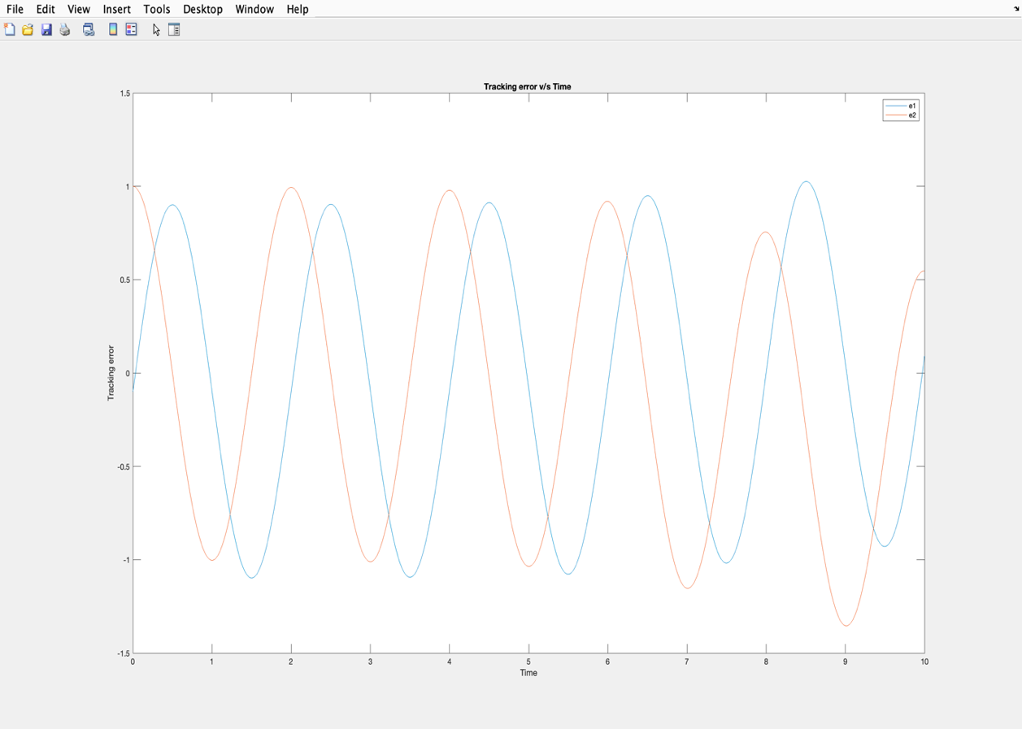

Joint angle graph:

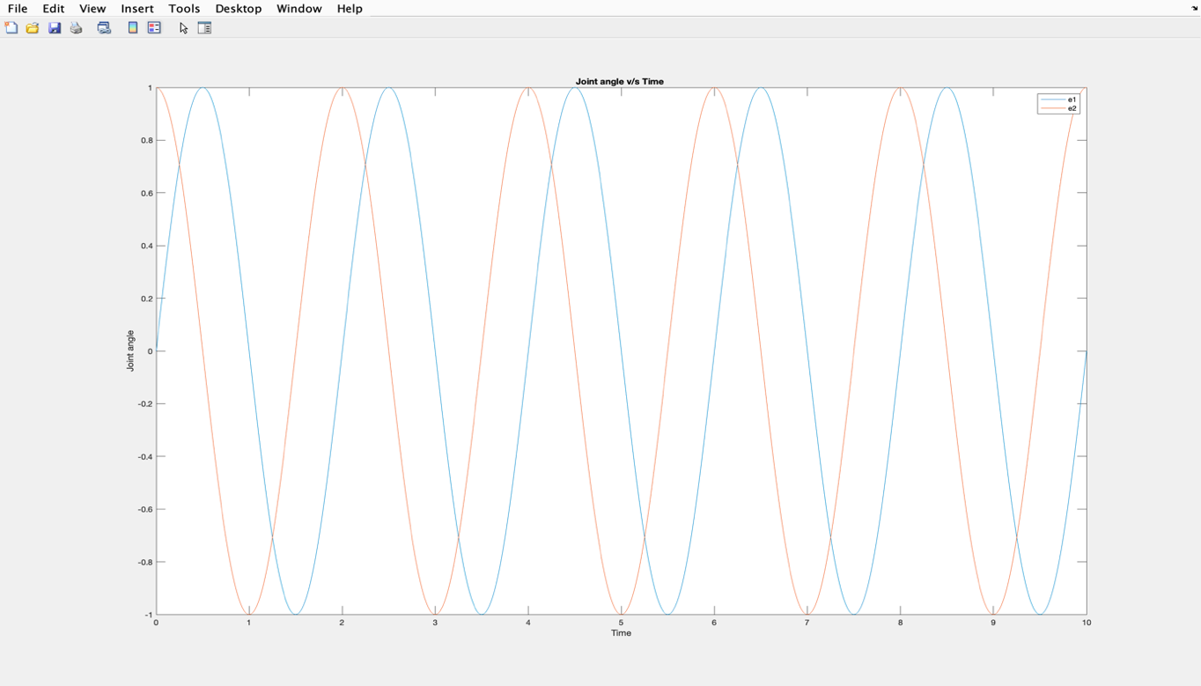

Conclusion:

The FLNN controller was successfully implemented and outputs obtained were verified

1. **Fblinct code**

% MATLAB file for closed-loop system simulation

function xdot= fblinct(t,x)

T=10;

% Computation of the desired trajectory

yD= sin(2*pi*t/T) ;

yDdot= (2*pi/T) * cos(2*pi*t/T) ;

yDddot=-(2*pi/T)^2 * sin(2*pi*t/T) ;

% Computation of the control input

kp= 100 ;

kd= 14.14 ;

f = sin(x(1)) + x(2)*x(3) + x(1)*x(2)^2 ;

g=1+ x(1)^2 ;

y = x(1) ;

ydot= x(1)*x(2) + x(3) ;

e=yD-y;

edot= yDdot- ydot ;

u = (-f + yDddot + kd*edot + kp*e)/g;

% Plant dynamics

xdot(1) = x(1)*x(2) + x(3) ;

xdot(2) =-2*x(2) + x(1)*u ;

xdot(3) = sin(x(1)) + 2*x(1)*x(2)+u;

xdot=xdot';

end

**8.Fblinct script file**

clear all; clc;close all;

t0= 0 ; tf=10 ;

x0= [0.1 0 0 0 0 0]' ;

T=10;

[t,x] = ode23('fblinct', [t0 tf], x0);

y=x;

yd= sin(2*pi*t/T) ;

e= yd - y ;

figure;

plot(t,[yd,x(:,1)])

figure;

plot(t,e)

figure;

plot(t,x(:,2))

**Implementation of FBLINCT controller:**

Output graph:

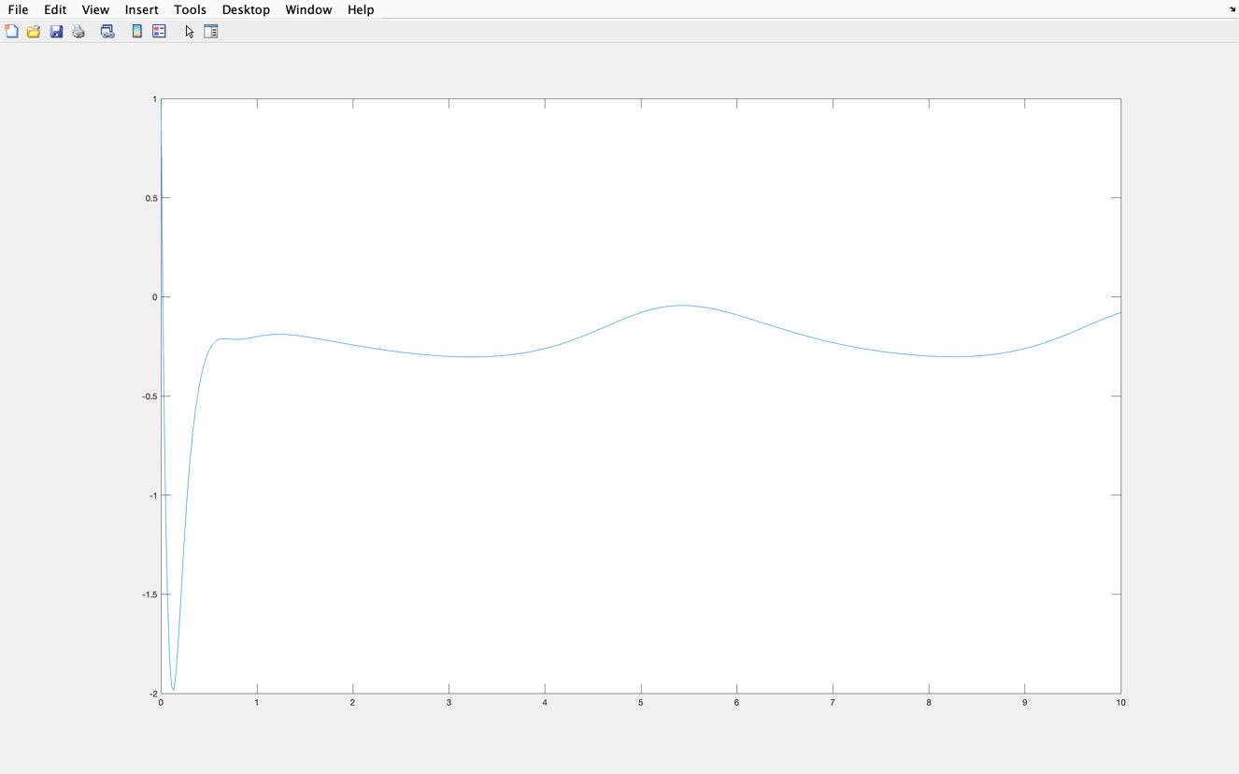

Joint angle graph:

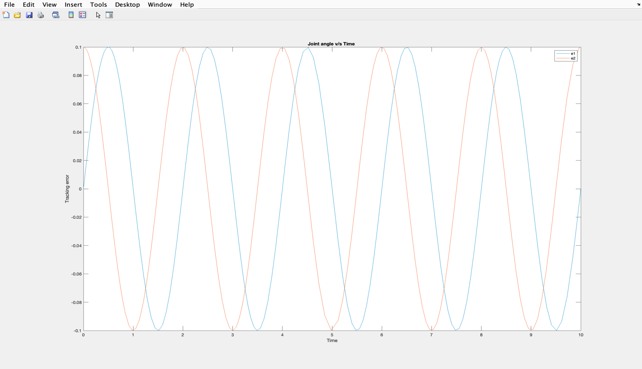

Tracking error graph:

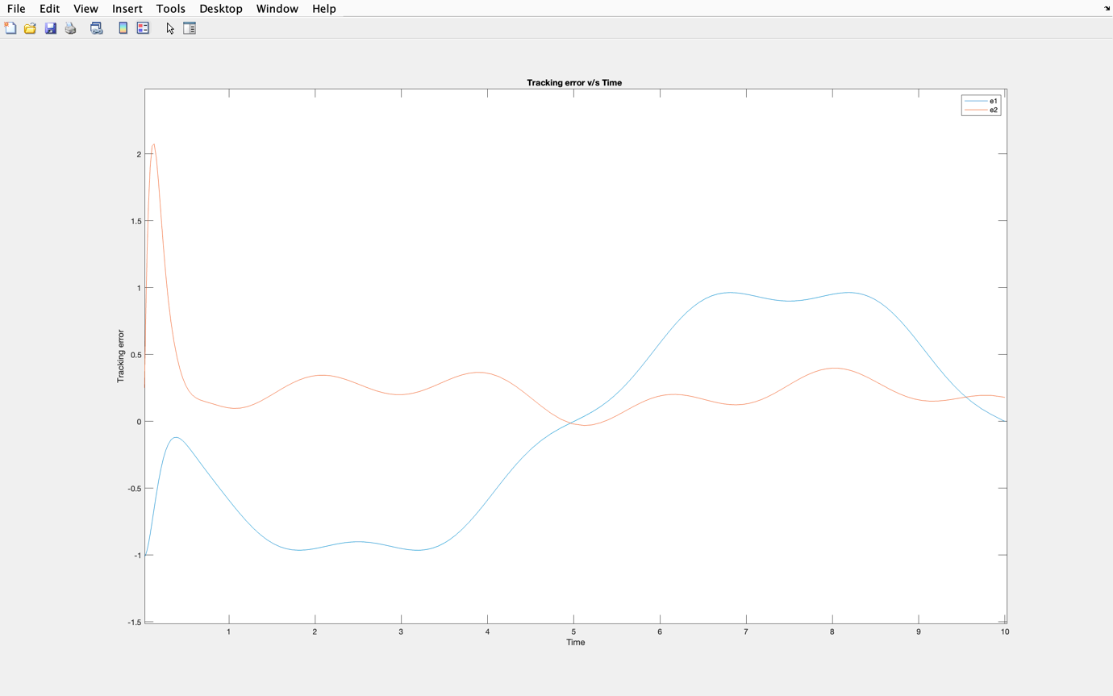

Conclusion:

The FBLINCT controller was successfully implemented and outputs obtained were verified

**THANK YOU ALL!**